|  |  |
| --- | --- |
| Course Name | ITD 2313 – Script Programming |
| Instructor | Mark L. Pranger |
| Student Name | Thomas Webb |
| Due date | 7/15/2025 |
| Grade | Put grade earned here |
| Grading Comments | Put instructor comments here |

Page 156

Page 157

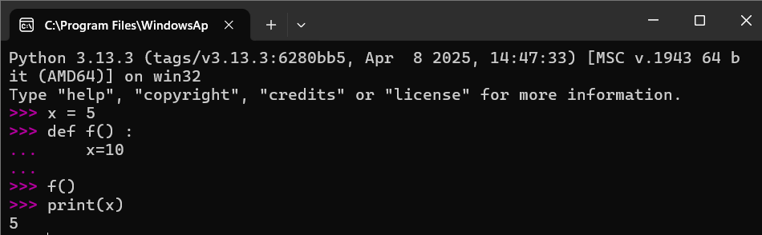

Page 158

Part 1

Part 2

Page 166

Part 1

Part 2

Part 3

Page 168-169

Part 1

Page 170

Page 179

Page 180

Page 181-182

Part 1

Part 2

Part 3

